**PROCESS INSTRUMENTATION**

**Name: Vivek Chandrashekhar Rugale**

**GR No.: 11810369**

**Div.: TY-C**

**Roll No.: 24 (Batch B1)**

**LAB 6:**

**Aim - Study of conventional and intelligent temperature transmitters**

Implementation of RTD Intelligent transmitter features (voting and averaging logic) using Python:

Python Code:

*print("Enter the output of 3 RTDs :")*

*a = int(input("RTD 1: "))*

*b = int(input("RTD 2: "))*

*c = int(input("RTD 3: "))*

*if(a==b==c):*

*print("\nVoting Logic Output: " + str(a))*

*else:*

*if(a==b):*

*print("\nVoting Logic Output: " + str(a))*

*elif(b==c):*

*print("\nVoting Logic Output: " + str(b))*

*else:*

*print("\nAveraging Output: " + str((a+b+c)/3))*

Output:

Voting Logic:

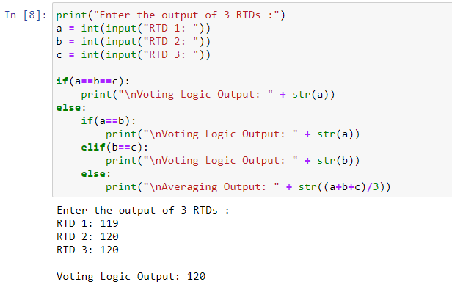

Averaging:

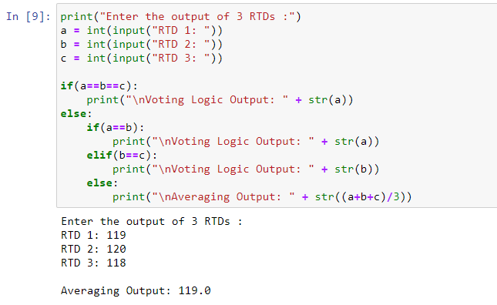

**Conclusion:**

Studied conventional and intelligent temperature transmitters. Implemented voting and averaging logic of intelligent transmitters using python programming.